**Visvesvaraya Technological University**

jnana sangama, BelAGAVI – 590 018

**A Report on**

***ONLINE GAMES DISTRIBUTION PLATFORM***

*Submitted in partial fulfillment of the requirements as a part of the DBMS Lab for the award of degree of*

**Bachelor of Engineering**

**In**

**Information Science and Engineering**

Submitted by

**Archit Raj Anshuman**

**1RN16IS016 1RN16IS104**

**Faculty In charge**

**R. Raj Kumar**

**Asst. Professor**

**Dept. of ISE, RNSIT**



**Department of Information Science and Engineering**

**RNS Institute of Technology**

Channasandra, Dr. Vishnuvardhan Road, RR Nagar Post,

Bengaluru – 560 098

2018 – 2019

**RNS Institute of Technology**

Channasandra, Dr.Vishnuvardhan Road, RR Nagar Post,

Bengaluru – 560 098

**Department of Information Science & Engineering**



**CERTIFICATE**

This is to certify that the internship report entitled ***ONLINE GAMES DISTRIBUTION PLATFORM*** has been successfully completedby **ARCHIT RAJ** bearingUSN **1RN6IS016**, and **ANSHUMN** bearing USN **1RN16IS016** presently V semester student of **RNS Institute of Technology** in partial fulfillment of the requirements as a part of the DBMS Laboratory for the award of the degree***Bachelor of Engineering in Information Science and Engineering*** under**Visvesvaraya Technological University, Belagavi**during academic year 2018 – 2019. It is certified that all corrections/suggestions indicated for Internal Assessment have been incorporated in the report deposited in the departmental library. The mini project report has been approved as it satisfies the academic requirements as a part of DBMS Laboratory for the said degree.

**Mr. R Rajkumar Dr. M V Sudhamani**

Faculty In charge Professor and HOD

Assistant Professor

# External Viva

**Name of the Examiners Signature with date**

1. _________________ __________________
2. ________________ ___________________

**ABSTRACT**

Over the years we have seen a great boom in computers and now we find ourselves surrounded by them. We use Computers in various ways, some of them being office work, purchasing products online, booking tickets online, etc. Computers are widely used for entertainment purposes such as watching online videos, movies, social media, games, etc. So we provide an online platform where the developers of the game and the people who are interested can communicate. We allow developers to publish their game on our platform, and users may buy the game from the developers through our platform. This is way easier as developers need not produce hard copy of the game and the users will not have to go to stores to buy the game.

We have used Database Management System to implement this idea. We used HTML and CSS for front-end and C# for back-end development.

DBMS provides an efficient way for storing data in tabular format. It provides simple yet efficient way to insert, update, delete or retrieve the data stored. C# is a software that interacts with DBMS for data transfers involved. HTML and CSS are used to present the data in a presentable way for the end user.

**ACKNOWLEDGMENT**

The fulfillment and rapture that go with the fruitful finishing of any assignment would be inadequate without the specifying the people who made it conceivable, whose steady direction and support delegated the endeavors with success.

I would like to profoundly thank **Management** of **RNS Institute of Technology** for providing such a healthy environment to carry out this Project work.

I would like to thank our beloved Director **Dr. H N Shivashankar** for his confidence feeling words and support for providing facilities throughout the course.

I would like to express my thanks to our Principal **Dr. M K Venkatesha** for his support and inspired me towards the attainment of knowledge.

I wish to place on record my words of gratitude to **Dr. M V Sudhamani,** Professor and Head of the Department, Information Science and Engineering, for being the enzyme and master mind behind my Project work.

I would like to express my profound and cordial gratitude to my Faculty in charge **Mr. R Rajkumar**, Assistant Professor, Department of Information Science and Engineering for their valuable guidance, constructive comments and continuous encouragement throughout the Project work.

I would like to express my profound and cordial gratitude to my guide **Mrs Kusuma S**, Assistant Professor, Department of Information Science and Engineering for their valuable guidance in preparing Project report.

I would like to thank all other teaching and non-teaching staff of Information Science & Engineering who have directly or indirectly helped me to carry out the project work.

And lastly, I would hereby acknowledge and thank my parents who have been a source of inspiration and also instrumental in carrying out this Project work.

**ARCHIT RAJ ANSHUMAN**

**USN: 1RN16IS106 USN: 1RN16IS016**

**TABLE OF CONTENTS**

**CERTIFICATE**

**ABSTRACT i**

**ACKNOWLEDGEMENT ii**

**TABLE OF CONTENTS iii**

**LIST OF FIGURES iv**

**1. INTRODUCTION 1**

1.1 Background

1.2 Introduction to the title of the project

**2. E R DIAGRAM 4**

**3. RELATIONAL SCHEMA DIAGRAM 5**

**4. SYSTEM DESIGN 6**

4.1 Tables 18

**5. IMPLEMENTATION**

5.1 Hardware and Software Requirement 9

5.2 Code Segment 10

5.2 Snapshots 15

**6. CONCLUSION 20**

**7. FUTURE ENHANCEMENTS 20**

**8. REFERENCES** 21

**LIST OF FIGURES**

**Fig no Name Pg. No**

* **2 E.R Diagram 4**
* **3 Schema 5**
* **4.1 Games Table 6**
* **4.2 Publisher table 6**
* **4.3 User Table 7**
* **4.4 Games owned table 7**
* **4.5 Payment table 8**
* **5.2.1 Welcome page 15**
* **5.2.2 Publisher Login 15**
* **5.2.3 Publisher dashboard 15**
* **5.2.4 Add new game 16**
* **5.2.5 Edit a game 16**
* **5.2.6 Editing Board 16**
* **5.2.7 Delete a Game 17**
* **5.2.8 User login 17**
* **5.2.9 User Dashboard 17**
* **5.2.10 Search For Game 18**
* **5.2.11 Search Result 18**
* **5.2.12 Transaction Page 18**
* **5.2.13 Administration login 19**
* **5.2.14 Administration Dashboard 19**
* **5.2.15 Publisher Registration 19**



# INTRODUCTION

**1.1 Background**

The Database Management System (DBMS) is software that enables the users to define, create, maintain and control the access to the database. It is a software that interact with the user’s applications programs and its database. The DBMS have the ability to store, update and retrieve the data. This is the main function of the DBMS because the database can be used if there is any record is being stored into the database. The record need to be retrieve first, then it can be change by the database administrator as it will be the record has been updated. The DBMS will protect the structure of the data structure. One of the main feature of DBMS is that it provides the facility for multiple access simultaneously, i.e. it allows several users to use the database all at the same time. This feature is quite useful for banks and online e-commerce websites.

The whole database is divided into number of tables and they have relation among them. The diagram showing these tables and relations among them is called Entity-Relationships Diagram (E-R Diagram). Based on this E-R Diagram the schema diagram is prepared which is the basic architecture of the database. According to the architecture or model of the database the tables, their attributes and relations among the tables are created using SQL.

Structured Query Language, also known as SQL, is utilized to interact with a database. Per ANSI (American National Standards Institute), it is the standard language for relational database management systems. SQL statements are utilized to perform tasks, for example, upgrade information on a database, or recover information from a database. “Some common relational database management systems that use SQL are: Oracle, Sybase, Microsoft SQL Server, Access, Ingres, etc. Although most database systems use SQL, most of them also have their own additional proprietary extensions that are usually only used on their system. However, the standard SQL commands such as "Select", "Insert", "Update", "Delete", "Create", and "Drop" can be used to accomplish almost everything that one needs to do. Microsoft SQL is the SQL used in this project.

C# is a type-safe and sophisticated object-oriented language that allows designers to construct a range of protected and robust applications that work on the .NET Framework. It can be used to develop Windows customer applications, XML Web services, dispersed parts, client-server applications, database applications, etc. In this project we have used C# as back-end software that interacts with the database through Microsoft SQL.

HTML (Hypertext Markup Language) and CSS (Cascading Style Sheet) are the languages used display the data in a presentable manner as a web page in the browser. In this project we have used HTML and CSS for front-end development that displays the data retrieved from the database via SQL.

**1.2 Introduction to the title of the project**

Games have always been there in human civilization and now in the technically advances society the games have also advanced. They can be played on the computers and the mobile phones. Games are one of the modes of entertainment, it provides a relief from the stressed lives of todays. People enjoy playing games when they are alone or with friends. So, this projects provides a platform for people to enjoy playing games even more.

This project contains three major parts. Publisher, it is the developer who has developed the game and publishes it on the platform. User, it is the one who buys the games from the developers. Administrator, it is the one who owns the platform.

Publisher is the group of people or individual that develops the game and publishes his game on this platform for others to buy. There is a registration page where new publishers can register themselves. Once registered publisher can login to their account to view and manage the games that they have published. They publish a new game, edit an existing game or delete an existing game.

User is the person that plays the games that are published on the platform. User buys the game from the publisher via this platform. User registers himself through the registration page for users. Once registered he can login to this account and search for the games he wants to buy. When he makes a purchase the game is included in his library. Once a game is purchased, it remains in his library forever. He need not purchase the game if the game is updated. The purchase system is secure as it asks the user to re-enter the password and card details before the purchase. This platform provides the game online to be purchased and downloaded so that the publisher saves the expense of publishing the game’s hard copy and shipping it to physical stores. When new updates of the games is pushed the publisher need not produce hard copy of the update, thus saving the expense of the publisher as well as the user.

Administrator is the person who owns or runs this platform. He is the one who manages all the data and money transfer that takes place through this platform. He is the one who can see all the users and the publisher that have registered to this platform. Once logged in to his account he can view the list of users, games, publishers and the transaction that have occurred.

Last couple of years have seen a great increase in the gaming industry. E-Sports is the competitive gaming where professional gamers compete among each other to win the prize money. As the gaming industry is increasing and making huge amount of money there is great chance for good gamers to come up and build a professional career in this industry. It is expected that gaming industry will continue to increase in upcoming years thus increasing the scope of this platform.

**ER DIAGRAM**

An entity relationship model, also called an entity-relationship (ER) diagram, is a graphical representation of entities and their relationships to each other, typically used in computing in regard to the organization of [data](https://www.webopedia.com/TERM/D/data.html) within [databases](https://www.webopedia.com/TERM/D/database.html) or information systems. An entity is a piece of data-an [object](https://www.webopedia.com/TERM/O/object.html)or concept about which data is stored.

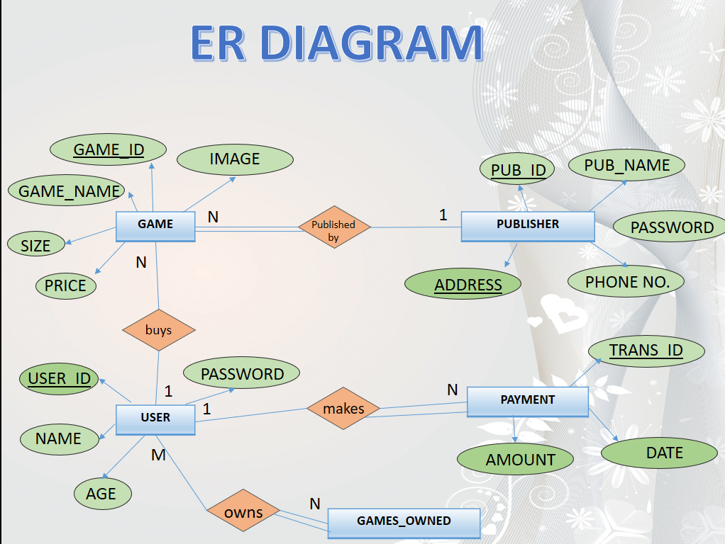

**SCHEMA**

A database schema is the skeleton structure that represents the logical view of the entire database. It defines how the data is organized and how the relations among them are associated. It formulates all the constraints that are to be applied on the data.

A database schema defines its entities and the relationship among them. It contains a descriptive detail of the database, which can be depicted by means of schema diagrams. It’s the database designers who design the schema to help programmers understand the database and make it useful.

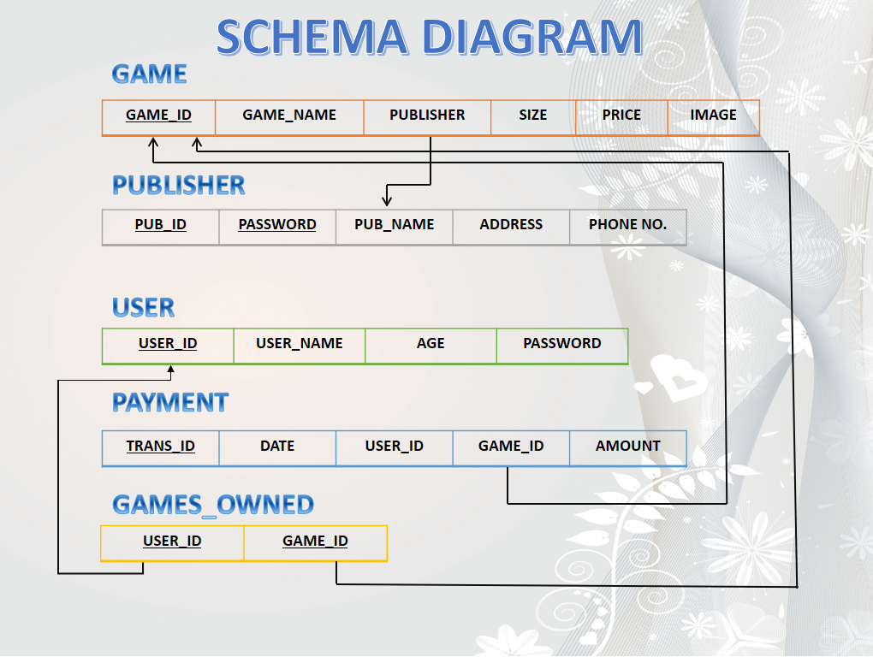

**SYSTEM DESIGN**

**4.1 TABLES**

GAMES

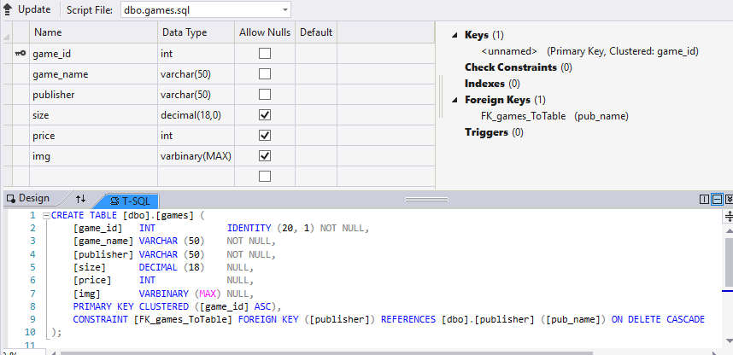

PUBLISHER

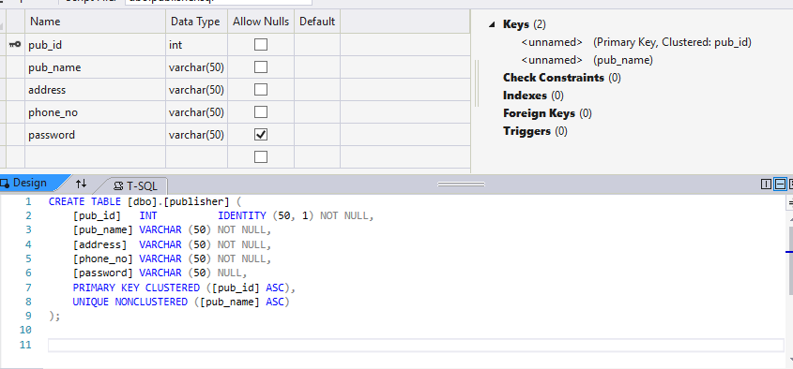

USER

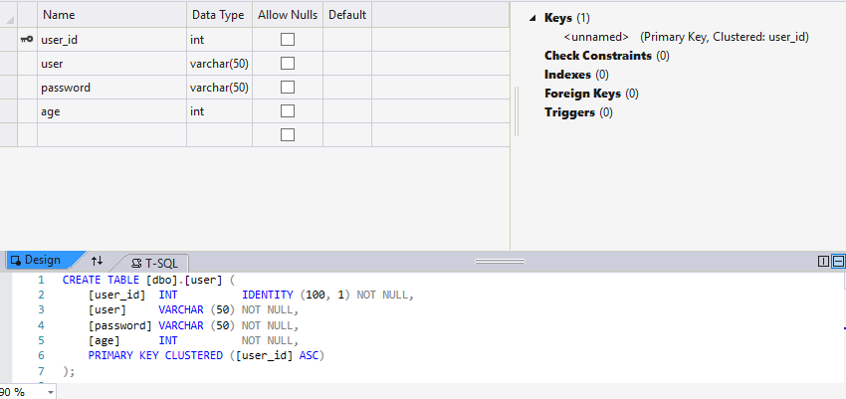

GAMES OWNED

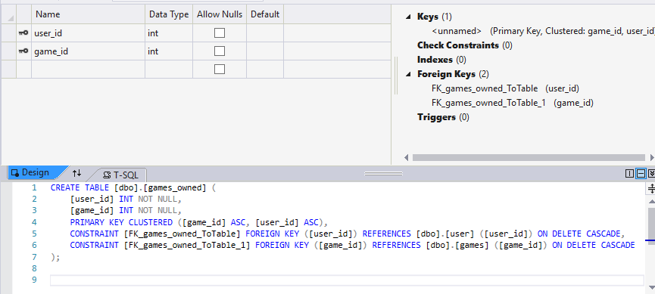

PAYMENT

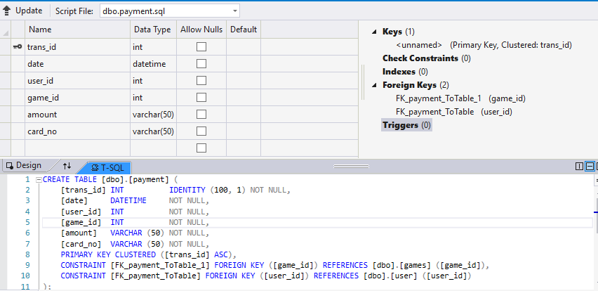

**SYSTEM REQUIREMENTS**

**3.1 Software requirement:-**

* Front End tools: HTML, CSS
* Back End tools: Visual Studio 2017, C#
* Browser that supports HTML and JavaScript
* IIS EXPRESS
* MS SQL Database

**3.2 Hardware requirement:-**

* CPU: Pentium processor and above
* RAM: 2 GB
* HDD: 40 GB

**CODE SEGMENT**

**LOGIN**

using System;

using System.Collections.Generic;

using System.Linq;

using System.Web;

using System.Web.UI;

using System.Web.UI.WebControls;

using System.Data.SqlClient;

using System.Data.Sql;

namespace dbms_project.login

{

public partial class WebForm2 : System.Web.UI.Page

{

SqlConnection con = new SqlConnection(@"Data Source=(LocalDB)\MSSQLLocalDB;AttachDbFilename=E:\Users\Archit\source\repos\dbms project\dbms project\App_Data\mydata.mdf;Integrated Security=True");

protected void Page_Load(object sender, EventArgs e)

{ }

protected void Button1_Click(object sender, EventArgs e)

{SqlCommand com = new SqlCommand("Lgn", con);

com.CommandType = System.Data.CommandType.StoredProcedure;

SqlParameter p1 = new SqlParameter("@user", TextBox1.Text);

SqlParameter p2 = new SqlParameter("@password", TextBox2.Text);

com.Parameters.Add(p1);

com.Parameters.Add(p2);

con.Open();

SqlDataReader rd = com.ExecuteReader();

if (rd.HasRows)

{

rd.Read();

string st = TextBox1.Text;

Session["login"] = st;

Response.Redirect("user.aspx");

}

else

{

Label1.Text = "Invalid username or password.";

Label1.Visible = true;

}}}}

Stored Procedure

CREATE procedure [dbo].[Lgn]

( @user varchar(50),

@password varchar(50)

)

as

SELECT * FROM [dbo].[user] WHERE [user] = @user AND password=@password

Registration page

namespace dbms_project

{public partial class WebForm1 : System.Web.UI.Page

{

SqlConnection con = new SqlConnection(@"Data Source=(LocalDB)\MSSQLLocalDB;AttachDbFilename=E:\Users\Archit\source\repos\dbms project\dbms project\App_Data\mydata.mdf;Integrated Security=True");

protected void Page_Load(object sender, EventArgs e)

{

}

protected void Button1_Click(object sender, EventArgs e)

{try {

if (TextBox3.Text == "" || TextBox2.Text == "" || TextBox4.Text=="")

{ Label6.Text = "fields can not be empty";

}

else

{SqlCommand cmd = new SqlCommand("insert into [dbo].[user] values (@user,@password, @age )", con);

cmd.Parameters.AddWithValue("@user", TextBox3.Text);

cmd.Parameters.AddWithValue("@password", TextBox2.Text);

cmd.Parameters.AddWithValue("@age", TextBox4.Text);

con.Open();

cmd.ExecuteNonQuery();

con.Close();

Label5.Text = "User registered successfully";

Response.Redirect("~/login/WebForm2.aspx");

}

}

catch

{

Label6.Text = "fields can not be empty";

}}}}

**Deletion page**

namespace dbms_project.publisher_login

{ public partial class pdelete : System.Web.UI.Page

{SqlConnection con = new SqlConnection(@"Data Source=(LocalDB)\MSSQLLocalDB;AttachDbFilename=E:\Users\Archit\source\repos\dbms project\dbms project\App_Data\mydata.mdf;Integrated Security=True");

protected void Page_Load(object sender, EventArgs e)

{}

protected void Button1_Click(object sender, EventArgs e)

{ string st = TextBox1.Text;

SqlCommand cmd = new SqlCommand("select count(*) from games where game_name=@u and publisher=@p;", con);

cmd.Parameters.AddWithValue("@u", TextBox1.Text);

cmd.Parameters.AddWithValue("@p", Session["add"].ToString());

con.Open();

string i = cmd.ExecuteScalar().ToString();

int rd = int.Parse(i);

if (rd != 0)

{if( MessageBox.Show("do u really wanna delete the record", "message", MessageBoxButtons.YesNo) == DialogResult.Yes)

{

SqlCommand cmd2 = new SqlCommand("delete from games where game_name=@u and publisher=@p;", con);

cmd2.Parameters.AddWithValue("@u", TextBox1.Text);

cmd2.Parameters.AddWithValue("@p", Session["add"].ToString());

cmd2.ExecuteNonQuery();

Label1.Text = "Game Deleted";

}

}

else

{ Label1.Text = "Game Not Found";

}}}}

Update page

namespace dbms_project.publisher_login

{ public partial class pedit : System.Web.UI.Page

{ string n, p, s,name;

SqlConnection con = new SqlConnection(@"Data Source=(LocalDB)\MSSQLLocalDB;AttachDbFilename=E:\Users\Archit\source\repos\dbms project\dbms project\App_Data\mydata.mdf;Integrated Security=True");

protected void Page_Load(object sender, EventArgs e)

{ name = Session["search"].ToString();

Label3.Text = "name";

Label4.Text = "size";

Label5.Text = "price";

string result1 = "select game_name from games where game_name=@u and publisher=@p";

SqlCommand showresult1 = new SqlCommand(result1, con);

showresult1.Parameters.AddWithValue("@u",name);

showresult1.Parameters.AddWithValue("@p", Session["add"].ToString());

con.Open();

n = Label10.Text = showresult1.ExecuteScalar().ToString();

string result2 = "select size from games where game_name=@u and publisher=@p";

SqlCommand showresult2 = new SqlCommand(result2, con);

showresult2.Parameters.AddWithValue("@u", name);

showresult2.Parameters.AddWithValue("@p", Session["add"].ToString());

s = Label11.Text = showresult2.ExecuteScalar().ToString();

string result3 = "select price from games where game_name=@u and publisher=@p";

SqlCommand showresult3 = new SqlCommand(result3, con);

showresult3.Parameters.AddWithValue("@u", name);

showresult3.Parameters.AddWithValue("@p", Session["add"].ToString());

p = Label12.Text = showresult3.ExecuteScalar().ToString();

SqlCommand cmd = new SqlCommand("select img from games where game_name=@u and publisher=@p", con);

cmd.Parameters.AddWithValue("@u", name);

cmd.Parameters.AddWithValue("@p", Session["add"].ToString());

SqlDataReader dr = cmd.ExecuteReader();

GridView1.DataSource = dr;

GridView1.DataBind();

con.Close();

TextBox1.Visible = false;TextBox2.Visible = false;TextBox3.Visible = false;Button4.Visible = false;Button5.Visible = false;Button6.Visible = false;

}

protected void Button1_Click(object sender, EventArgs e)

{ TextBox1.Visible = true;

Button4.Visible = true;

}

protected void Button2_Click(object sender, EventArgs e)

{ TextBox2.Visible = true;

Button5.Visible = true;

}

protected void Button3_Click(object sender, EventArgs e)

{ TextBox3.Visible = true;

Button6.Visible = true;

}

protected void Button4_Click(object sender, EventArgs e)

{ if (TextBox1.Text == "")

Label16.Text = "No value is entered";

else

{string result = "update games set game_name=@n where game_name=@a and publisher=@b";

SqlCommand showresult = new SqlCommand(result, con);

showresult.Parameters.AddWithValue("@n", TextBox1.Text.ToString());

showresult.Parameters.AddWithValue("@a", Session["search"].ToString());

showresult.Parameters.AddWithValue("@b", Session["add"].ToString());

con.Open();

showresult.ExecuteNonQuery();

con.Close();

string result1 = "select game_name from games where game_name=@u and publisher=@p";

SqlCommand showresult1 = new SqlCommand(result1, con);

showresult1.Parameters.AddWithValue("@u", TextBox1.Text.ToString());

showresult1.Parameters.AddWithValue("@p", Session["add"].ToString());

con.Open();

Label10.Text = showresult1.ExecuteScalar().ToString();

con.Close(); Button4.Visible = false;

Session["search"] = TextBox1.Text.ToString();

TextBox1.Text = "";

TextBox1.Visible = false;}

}

protected void Button6_Click(object sender, EventArgs e)

{ if (TextBox2.Text == null)

{ Label16.Text = "No value is entered";

}

else

{string result = "update games set price=@n where game_name=@a and publisher=@b";

SqlCommand showresult = new SqlCommand(result, con);

showresult.Parameters.AddWithValue("@n", TextBox3.Text.ToString());

showresult.Parameters.AddWithValue("@a", name);

showresult.Parameters.AddWithValue("@b", Session["add"].ToString());

con.Open();

showresult.ExecuteNonQuery();

con.Close();

string result1 = "select price from games where game_name=@u and publisher=@p";

SqlCommand showresult1 = new SqlCommand(result1, con);

showresult1.Parameters.AddWithValue("@u", name);

showresult1.Parameters.AddWithValue("@p", Session["add"].ToString());

con.Open();

Label12.Text = showresult1.ExecuteScalar().ToString();

con.Close();

}

}

protected void Button5_Click(object sender, EventArgs e)

{if (TextBox3.Text == null)

Label16.Text = "No value is entered";

else

{ string result = "update games set size =@n where game_name=@a and publisher=@b";

SqlCommand showresult = new SqlCommand(result, con);

showresult.Parameters.AddWithValue("@n", TextBox2.Text.ToString ());

showresult.Parameters.AddWithValue("@a",name);

showresult.Parameters.AddWithValue("@b", Session["add"].ToString());

con.Open();

showresult.ExecuteNonQuery();

con.Close();

string result1 = "select size from games where game_name=@u and publisher=@p";

SqlCommand showresult1 = new SqlCommand(result1, con);

showresult1.Parameters.AddWithValue("@u", name);

showresult1.Parameters.AddWithValue("@p", Session["add"].ToString());

con.Open();

Label11.Text = showresult1.ExecuteScalar().ToString();

con.Close();

}}}}

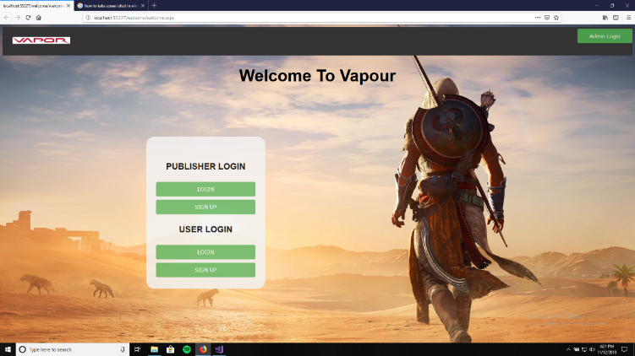**SNAPSHOTS**

**FIG(5.2.1) WELCOME PAGE**

This page provides the option of l login and sign up page for both user and publisher

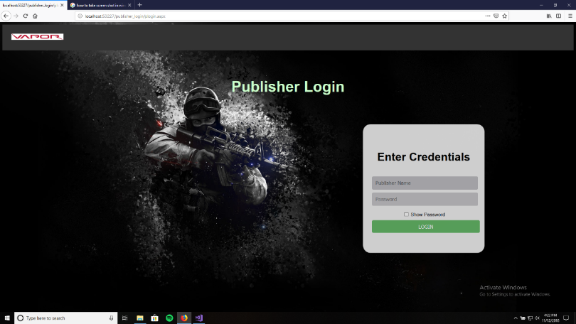

**Fig(5.2.2) Publisher Login**

This page is the login page for

Publishers where the publisher

Enter their name and password

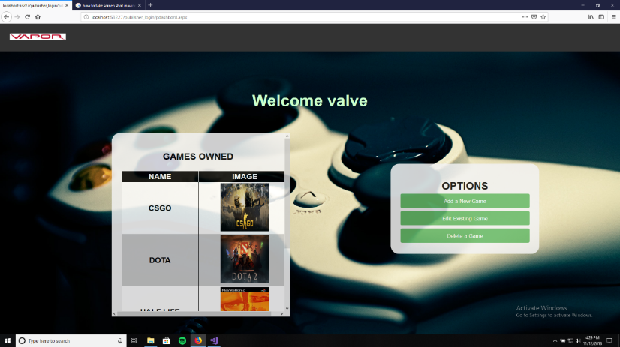

**Fig(5.2.3) Publisher Dashboard**

This page shows games owned by the publisher and provides

few options to the publisher

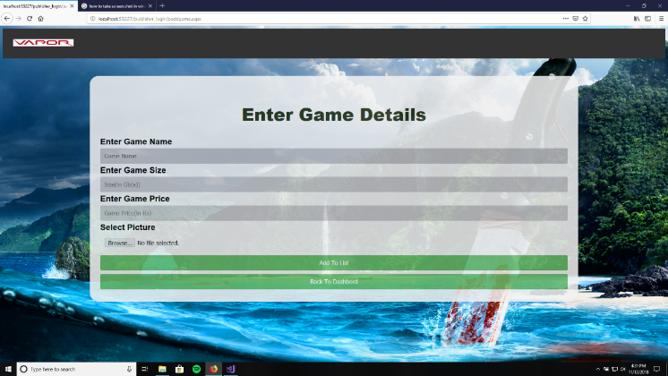

Fig(**5.2.**4) .**Add New Game**

This page provides the

option to insert new Game

by the publisher

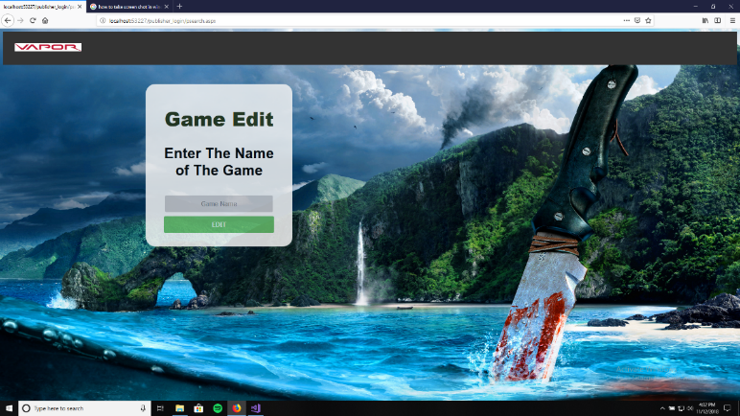

**Fig(5.2.5) Edit a Game**

This page ask the publisher

which game they want to

edit.

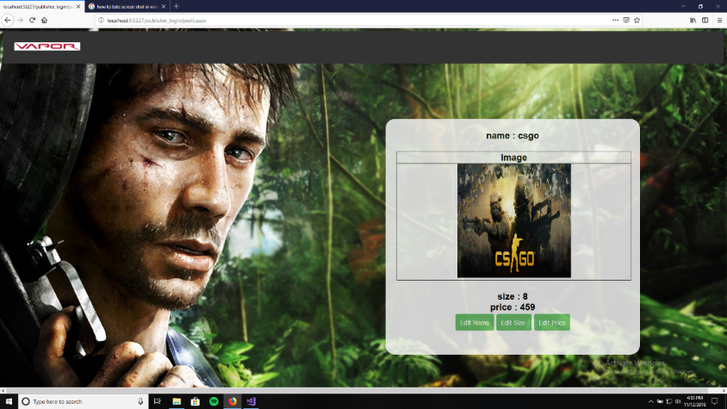

**Fig(5.2.6) Editing Board**

This page displays

the information about

game and provides the

option to edit it.

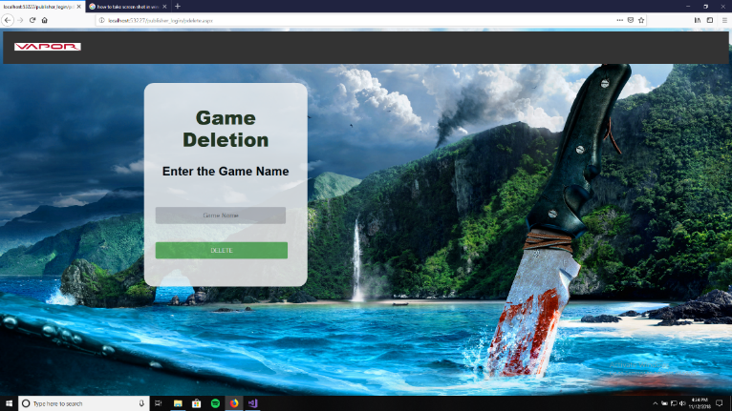

**Fig(5.2.7) Delete a Game**

This page asks the publisher

Which Game they want to

Delete.

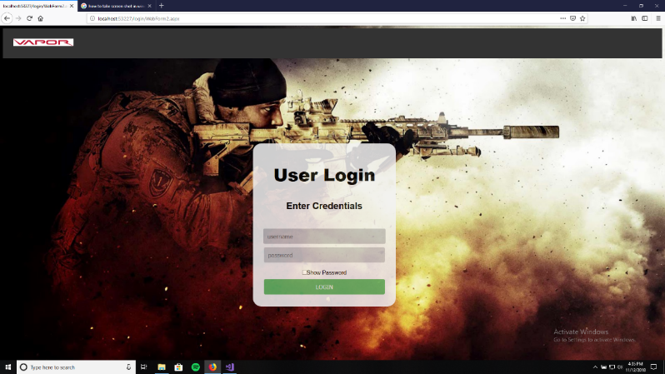

**Fig(5.2.8) User Login**

This page is the login page for

Users where the User

Enter their name and password

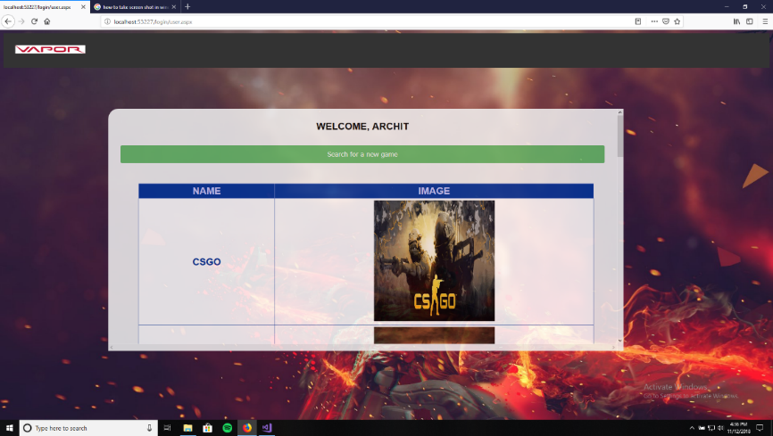

**Fig(5.2.9) User Dashboard**

This page shows the

Games owned by the user

And a search option

To find New Games.

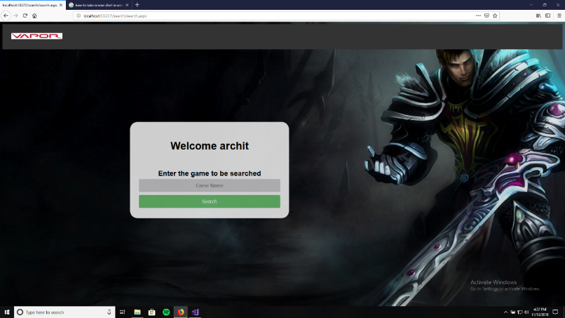**Fig(5.2.10) Searching for Game**

This page is used by the

User when they want to

Search for a new Game

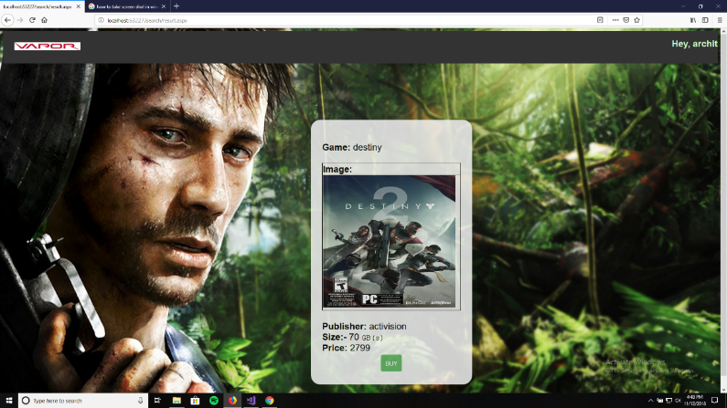

**Fig(5.2.11). Search Result**

This page shows the result

Of the search page

And gives the option of

Buying the Game

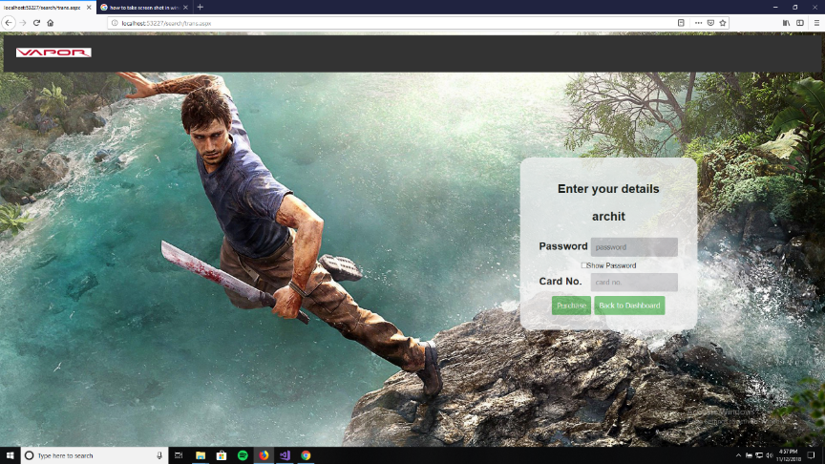

**Fig(5.2.12) .Transaction page**

This page asks the user

For their password and

The card no. to buy

The game

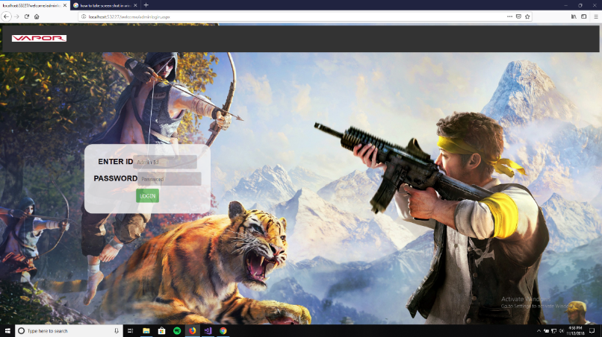

**Fig(5.2.13) Administration Login**

This page is used by the

Administrator to access

The data of the database

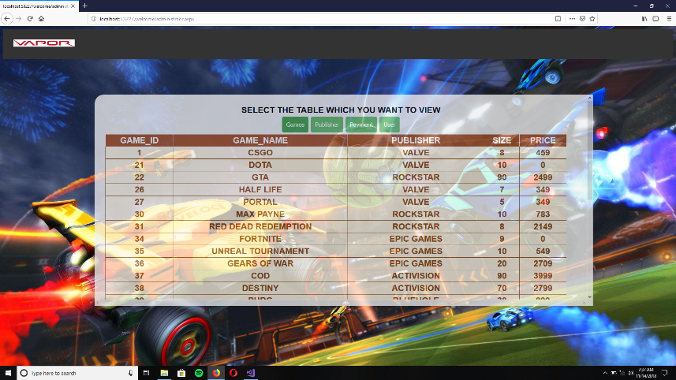

**Fig(5.2.14) Administrator**

**Dashboard**

This page shows the

Data of the tables present

The database

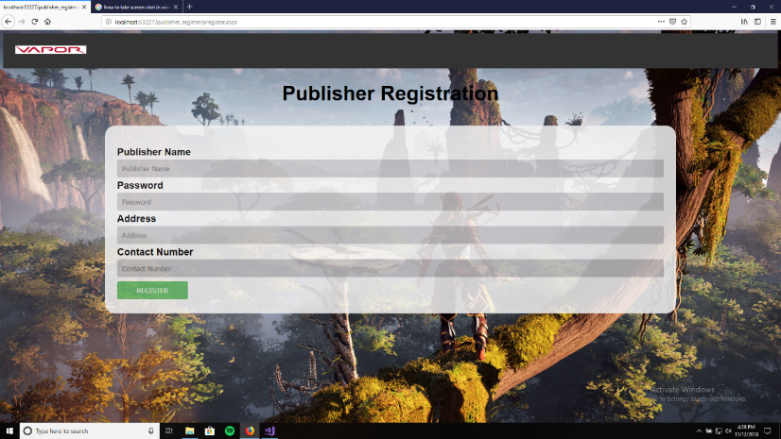

**Fig (5.2.15) Publisher Registration**

This page is used by

New publishers who want

To register themselves

**CONCLUSION**

This project will replace the traditional way of game distribution. The games were distributed through hard copies and the hard copies had to be preserved for future use. This platform eliminates this problem as it saves the data online. This project has very high potential to grow in future.

While implementing this project we came to know the real world problems and found a solution to the problem. During this project we learned about the basic Database Management System and how to implement it for real world problems.

To implement the idea behind the project we also learned basic C# for back-end development and HTML and CSS for front-end development. We now feel quite confident in the mentioned languages and can implement other projects using these languages.

**FUTURE ENHANCEMENT**

The current prototype is for limited amount of users and publishers, we need to increase the data capacity of this project so that it can be deployed as a final finished product.

Currently the games can be bought but not be downloaded. So, we need to implement a method through which a user can download the game from the publisher’s servers. Once the game is downloaded we need to implement a way through which the user can start the game via the platform rather than going to the files of the game to start the game.

We also need to implement a method through which users can download only the required files rather than the full game when a new update is released by the publisher.

We plan to implement a Chabot for better user and publisher experience. They can contact the Chabot for any query that may arise.

We also plan to implement a trial period of 2 days in which the user can play the purchased game and may opt for a refund if the game does not meets the expectations.

In the current prototype there is only one administrator, we need to add more administrators and provide more privileges to the administrator, such as when a player or user is not well mannered towards the other players the administrator can ban or delete his profile from the platform making him lose all his games.

**REFERENCES**

* [www.w3cschools.com](http://www.w3cschools.com)
* [www.c-sharpcorner.com](http://www.c-sharpcorner.com)
* [www.wikipedia.com](http://www.wikipedia.com)
* [www.stackoverflow.com](http://www.stackoverflow.com)
* Fundamentals of Database Systems (6th Edition) by Ramez Elmasri and Shamkant Navathe
* Database management systems (3rd edition) by Raghu Ramakrishna